**(1)Find a student average mark given mark1 and mark2.**

Algorithm:-

(a)start .

(b)Declare variable mark1,mark2,total and avg mark.

(c)Read values mark1 and mark2 .

(d)total mark1+mark2

(e)Avg total/2

(F)Display avg mark.

(g) Stop

**(2)Calculate the total fine charged by library for late return books .The charge is 0.20 INR per day.**

Algorithm:-

(a)Start

(b)Declare the number of days and change per day and total fine.

(c) Assign the value charge per day=0.20 INR

(d)Read values The number of day.

(e) Multiply the number of days with charge per day and assign the value to the total fine

(f) Total fione charge The number of days X 0.20

(g)Display total fine

(h)Stop

**(3)You had bought anice shirt which cost 29.90 with 15% discount. Count the net price for the shirt.**

(a)start

(b)Declare cost,discount,discounted cost and net price.

(c)initialize cost Rs 29.90 and discount 0.15

(d)Multiply cost with discount and assign the value to discounted cost.

Discounted cost cost X discount

(e)subtract the discounted cost from cost and assign the value to the net price.

Net price cost- discounted cost

(f) Display net price

(g)stop

**(4)find the smallest number among 3 different numbers.**

Algorithm:-

1. Start
2. Declare variable a,b &c
3. Read variable a,b &c
4. If a<b

If a<c

Display a is the smallest number

Else

Display c is the smallest number

Else if b<c

Display b is the smallest number

Else

Display c is the smallest number

(e)stop

**(5)Find the roots of a quadratic equation.**

Algorithm:-

(a)start

(b)input a,b,c

(c)d sqrt(b X b - 4 X a X c)

(d)x1 (-b +d)/(2 X a)

(e) x2 (-b +d)/(2 X a)

(f)print x1,x2

(g) stop

**(6)Find the factorial of a given number.**

Algorithm :-

1. Start
2. Read name n
3. Initialize the variable i and fact with the value 1.
4. Repeat step 4 through step 6 untill i=n .
5. Fact=fact X i
6. i=i+1
7. print fact
8. stop

**Flow chart**

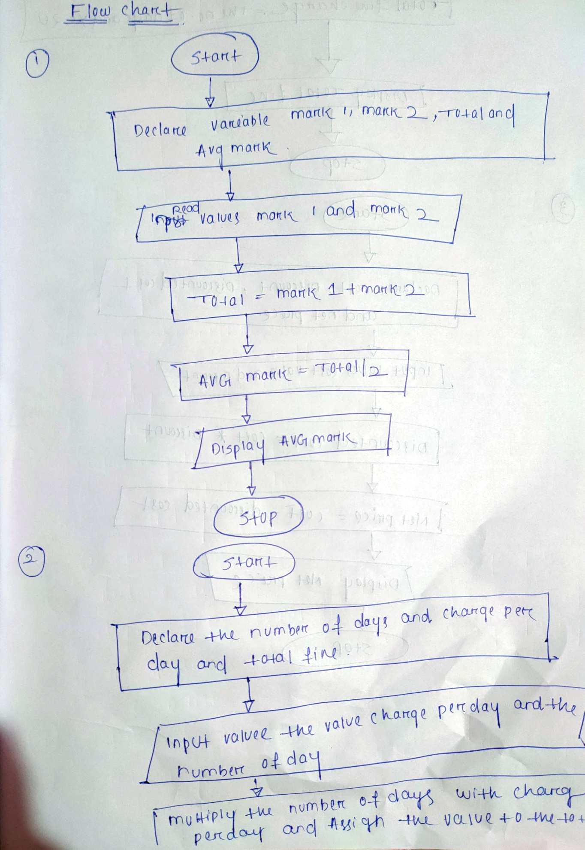

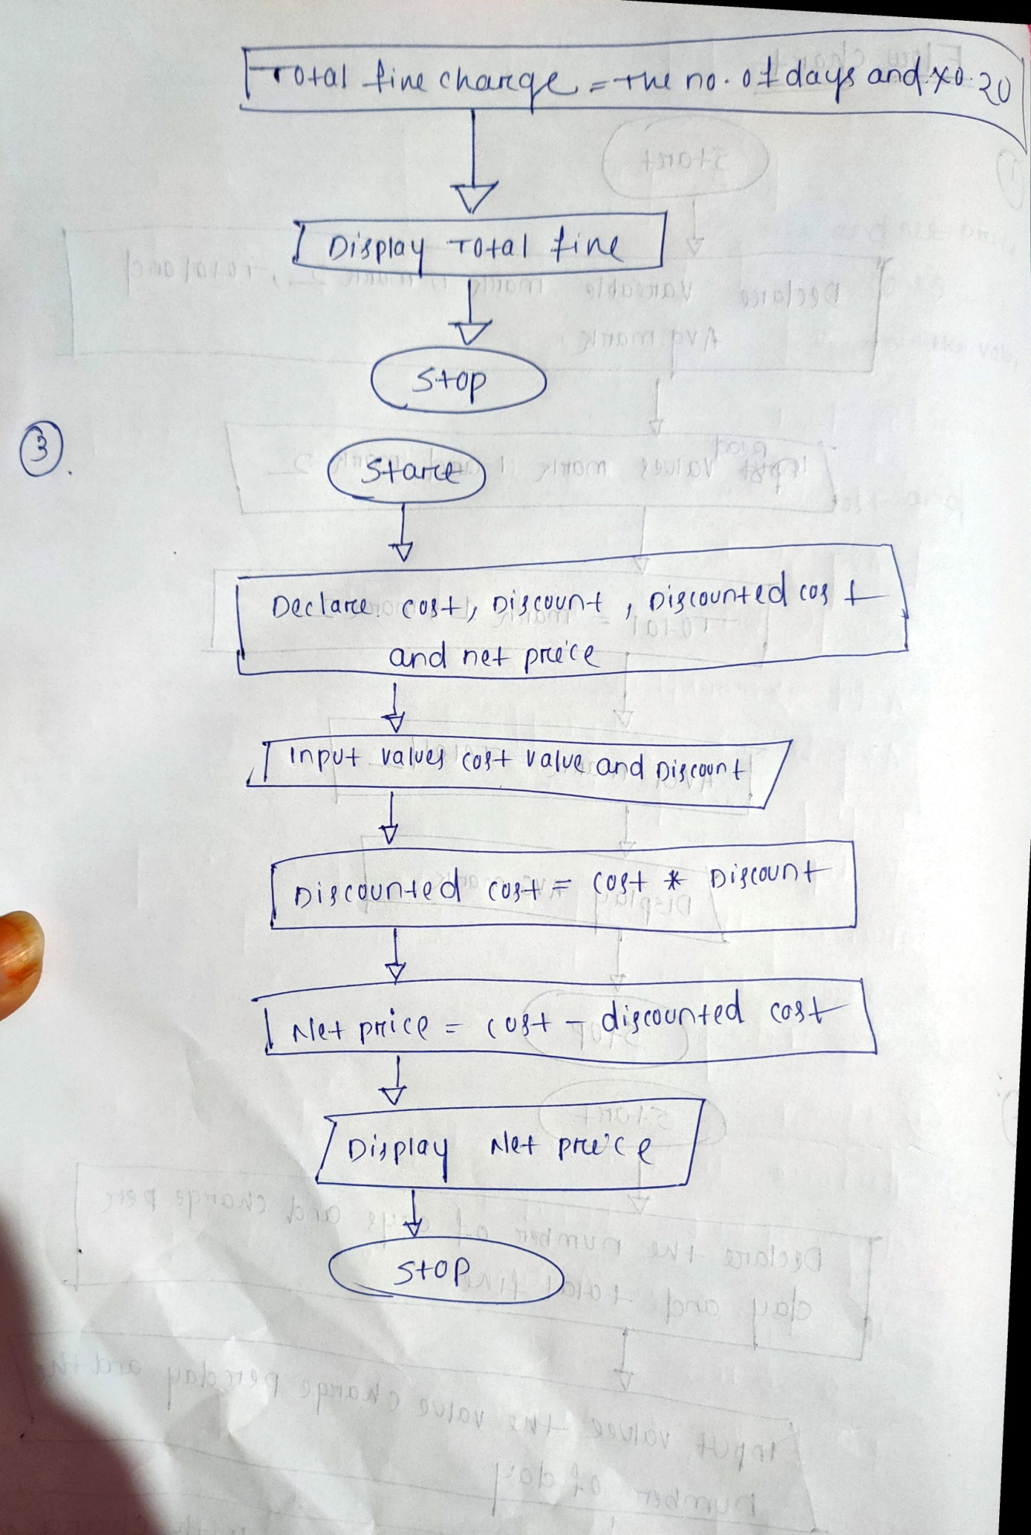

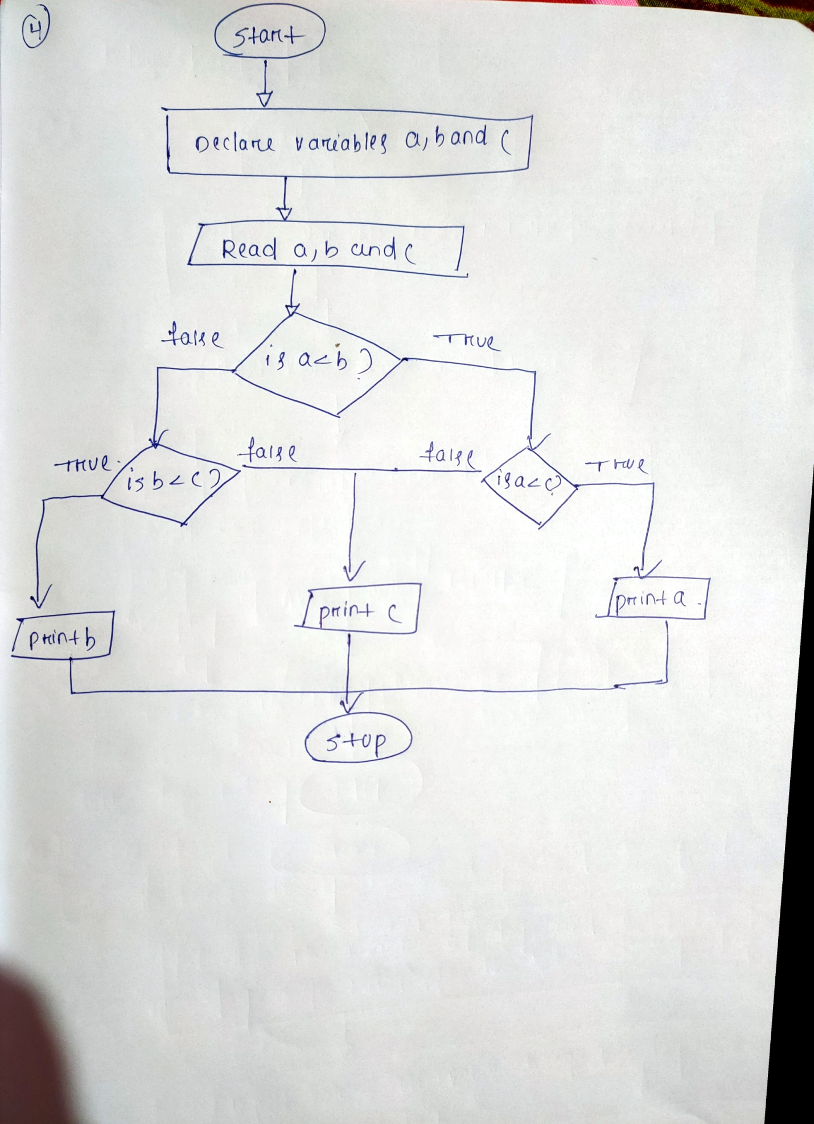

**(5)**

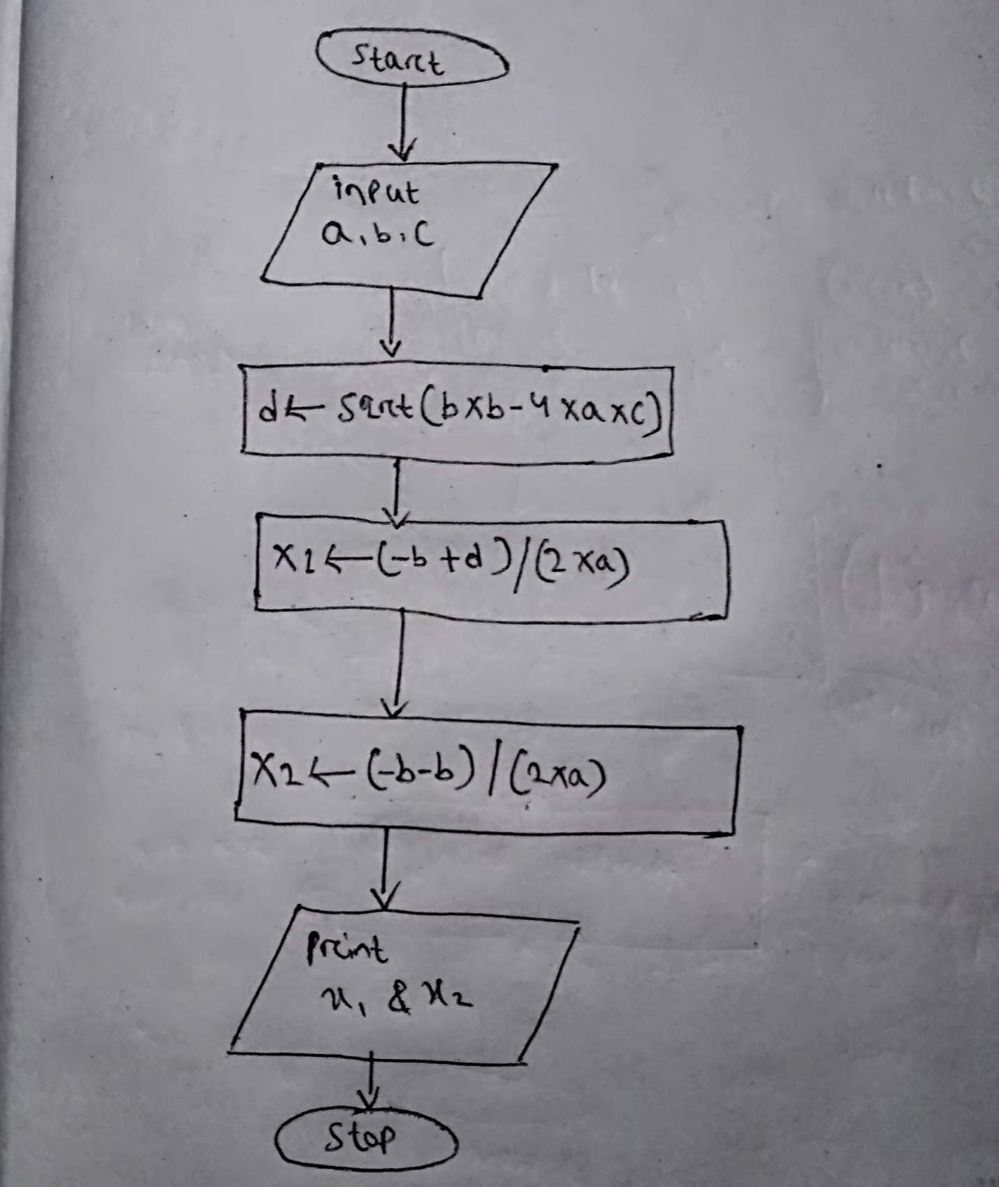

**(6)**

